E-commerce Business Plan

Lilian Antunes

Southern State University

Electronic Commerce System

June 16, 2023

**WEBSITE**

[**https://bluebird-reindeer-s5n9.squarespace.com/**](https://bluebird-reindeer-s5n9.squarespace.com/)

**PASSWORD: ROCCO**

**Executive Summary**

This paper provides an overview of the building of an E-store (ROCCO; an online women's clothing boutique. Designing a website (E-commerce business) is not easy as there are many steps and challenges involved to make it operational. The fashion and clothing industry is very competitive and the use of the internet is strong hence having an E-commerce portal is a necessity like ROCCO in the modern era. This business plan provides a detailed overview of ROCCO Company description, Marketing analysis, product line and marketing, and Sales Strategy that will help to build a competitive website (ROCCO). The business plan will greatly help to realize maximum profit from the site as ROCCO be a new destination for clothing products made from high-standard materials and unique and innovative designs at affordable prices with 24/7 customer service and discounts and offers.

**Company Description**

**ROCCO is an E-commerce venture that will deal with professional customized clothing and ready-wear collections for women. ROCCO offices and production units will be set up in San Diego California. The E-store aims to be the best online clothing store in the production of highly classy customized clothing and ready-wear collections for women. High-standard materials will be used such as Woven cotton and viscose such as knit fabrics and velvets to guarantee the best quality and uniqueness of ROCCO’s products. The venture will offer a variety of casual and highly classy customized clothing for women with unique designs. The ROCCO will be a sole proprietorship business as there a few legal requirements thus simple to establish.** The ROCCO’s products will entail protective “Riding Champions” apparel. Finally, its mission will be to establish a competitive site that with provide exceptional shopping experiences in superior and innovative designs and more fashionable suits and professional clothing collections to women in the United States.

**Market Analysis**

**The ROCCO target market will be professional women of 18 years to 45 years with good financial status from California and surrounding states I.e. Oregon, Arizona, and Nevada to expand its market to all women in the United States and Europe.** Fashion and clothing is competitive market and competitors have to race by understanding social matters, buyers' ever-changing tastes, and their satisfaction (Gazzola, et al…, 2020). **The Global size of the fashion and clothing market was valued at** USD 553.1 billion in 2021 and was expected to have a growth rate of 8.6 % from 2022 to 2030( Thomassey, 2018). The growth was attributed to the demand for clothing products in e-stores in the fashion and clothing industry. Also, the growth of the market was attributed to the increasing number of women working and constant innovations in the industry. Social media and celebrity influences also played a major role in the creation of new designs and styles. These aspects are anticipated to drive the clothing market over e-commerce sites during the forecast period (Thomassey, 2018).

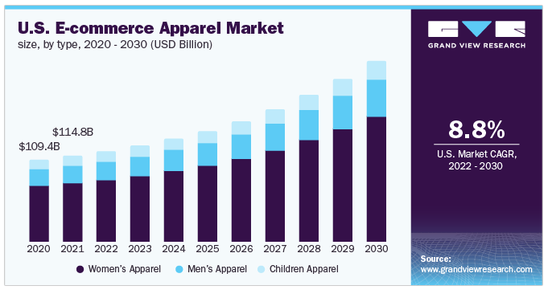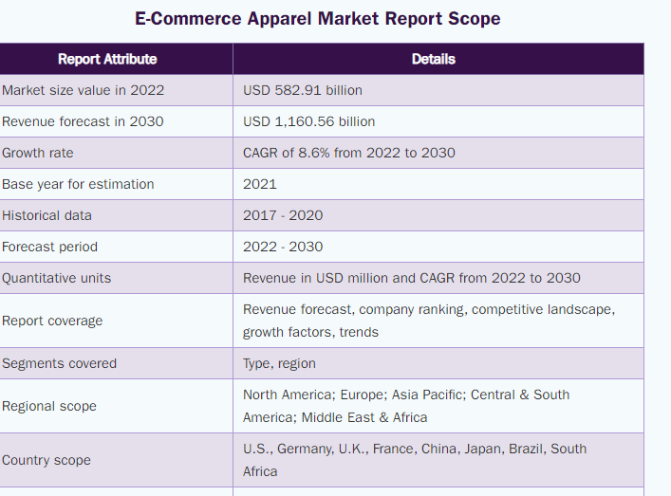

**Competitor analysis (SWOT analysis)**

The fashion and clothing industry is a combination of production (creation) and sales. I will use SWOT analysis to evaluate the competitive advantage of ROCCO), an e-commerce platform.

1. Strengths

1. ROCCO being a unique classy brand will attract customers from California and its neighboring states
2. Products will be presented online therefore; the cost of the physical property will be reduced thus selling its collection at affordable prices to customers. These reduced prices will attract more customers.

2. Weaknesses

The only weakness in the e-commerce platform among customers is uncertainty about the apparel relating to size, outlook, and fitness of clothing stuff.

3. Opportunities

The fashion and clothing industry is fast growing (Thomassey, 2018); I will tap the opportunity and use an influencer to promote the ROCCO site and even pay for adverts.

4. Threats

1. Privacy of customer’s Data.
2. Online transactions are prone to fraud
3. Big names in the market like Trove, Versace, Stylez, and Trendz among others.

**Product line**

ROCCO will deal with designing highly customized fashion, suits, sell classic ready –wear collections, and athleisure for women aged 18 -45 years. The apparel will be designed or made from high-standard materials such as woven cotton and Viscose such as knit fabrics and velvets to guarantee the best quality of ROCCO’s products. They will entail protective, ‘*Riding Champion’* apparel which will be derived from its name, ROCCO to make its products and boost the image of the company in the market. The high and innovative fashion and designs will attract new customers and drive more online sales through the e-commerce platform. There will be 24/7 customer service of professional stylists to ensure comfort is matched with fashion for professional women who are willing to spent their surplus income on luxury clothing.

**Marketing and sales strategy**

The E-commerce platform will be profiled with attractive and unique innovative fashion designs to show capability of the professional stylists of ROCCO in creation of high classic clothing apparel to attract customers to the site. Available courier services in San Diego such as Modern Express, A-1, Gold Rush among others to deliver products to customers’ pick-points. The cost of shipping the products will be reversed to the customer (F.OB). Digital marketing strategies will be used to market the site such as, social media marketing in channels that have high popularity of women ; Instagram, Facebook and Interest to reach a larger audience to drive online sales and also ensure customer satisfaction (Szozda, 2023). These SM channels will be prioritized because they attract more females compared to males as they allow sharing of pictures and videos (Busalim, & Ghabban, 2021).

Additionally, will reinforce social marketing with content marketing through blog writing and video marketing, and Search Engine Optimization (marketing which is aimed at promoting its image through keyword searches (Langley& Rieple, 2021). I will provide customers with easy access to information about ROCCO’s products in adverts and posts and enable feedback and reviews to keep them engaged and feel like they are vising a physical retail shop. Finally, I will make better use of social media and ROCCO's site and respond in time to direct messages and complaints to ensure customers are satisfied and actively engaged.

**Conclusion**

The Idea for ROCCO, an e-commerce platform is to fully maximize the changing trend of online shopping in the fashion and clothing industry. Therefore, well the implementation of discussed key points above, small ventures like ROCCO can compete and flourish fast with existing established online fashion ventures. Generally, the paper provides a comprehensive analysis of both practical and theoretical information in developing a sustainable business plan.

**References**

Busalim, A. H., & Ghabban, F. (2021). Customer engagement behavior on social commerce platforms: An empirical study. Technology in Society, 64, 101437.

Gazzola, P., Pavione, E., Pezzetti, R., & Grechi, D. (2020). Trends in the fashion industry. The perception of sustainability and circular economy: A gender/Generation quantitative approach. Sustainability, 12(7), 2809. <https://doi.org/10.3390/su12072809>

Langley, P., & Rieple, A. (2021). Incumbents' capabilities to win in a digitized world: The case of the fashion industry. Technological Forecasting and Social Change, 167, 120718. https://doi.org/10.1016/j.techfore.2021.120718

Szozda, N. (2023). Omnichannel as a driver of digitalization: evidence from the emerging market in the fashion industry. Journal of Fashion Marketing and Management: An International Journal, (ahead-of-print).

Thomassey, S. (2018). Sales forecasting in apparel and fashion industry: A review. Intelligent fashion forecasting systems: Models and applications, 9-27.